UNIT Overview | Unit Name: | Unit Code:
 | Unit Learning Outcomes (ULO): | Unit Description:

Assessment tasks
No. | Type of assessment  Description of assessment  Instructions for Student | Indicate if the assignment is graded or not graded (e.g. hurdle task). Indicate value (%). | Aligned to ULO number | Format of submission  (e.g. Word doc via TurnItIn) | Due Date & Time

ACU Assessment Policy – endorsed December 2015.
Please note that the updated policy and procedures state that, “The assessment schedule for any one 10 credit point unit must be limited to a maximum of three assessment tasks.”
Copy this page for each module in the Unit
Module 1 | Module/Week No & Name: | Module or Week LOs:  At the end of this module, you should be able to:  1.  2.  3. | Brief description of this module or week:
 | Aligns with ULOs:
Module 1 Learning Design:
Student Perspective |  |  |  |  |  |  | Lecturer / Facilitator
Sequence | Action  (E.g. listen, watch, read, write, reflect) | Time  (a guide for the students) | Module LO # | Learning Activity Description | Resource  (E.g. podcast, video, journal articles, book chapters etc) | Unit Assessment  (Which assessment item does this relate to?) | Teaching Activities  (You could also use this column to add notes for tutors and facilitators) | Time
1
2
3
4
Optional Activities | (E.g. Further reading etc)
Conclusion | (E.g. Read or answer etc) |  |  | (This could be a review, quiz or summary etc)

The image below depicts a partially completed example, using the template.
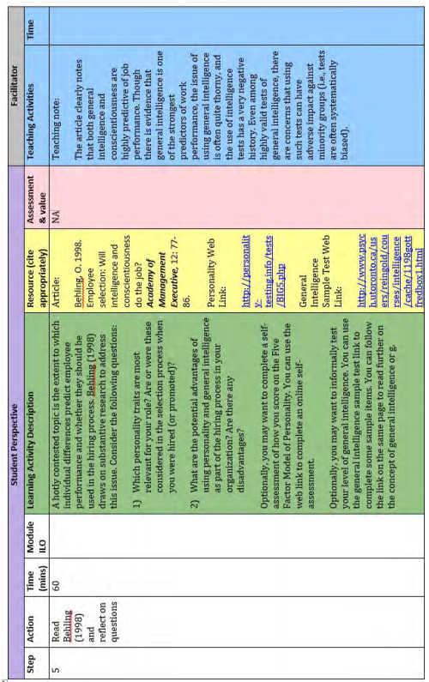
Image: (Weaver & Duque 2015)

